Experiment Name: Flag in Open GL

Introduction: This project, I will work how to use the fundamental forms of circle and rectangle and how to build a front-facing of a Flag Desing in OpenGL. Here, I draw Circle shape and draw a Flag.

Code: #include <GL/gl.h>

#include <GL/glut.h>

void display(void)

{

/* clear all pixels */

glClear (GL_COLOR_BUFFER_BIT);

/* draw white polygon (rectangle) with corners at

* (0.25, 0.25, 0.0) and (0.75, 0.75, 0.0)

*/

//quad shape

glBegin(GL_QUADS);

glColor3f(0,0.4156,0.3019);

glVertex3f(0.0f,00.0f, 0.0f);

glVertex3f(20.0f, 0.0f, 0.0f);

glVertex3f(20.0f, 10.0f, 0.0f);

glVertex3f(0.0f, 10.0f, 0.0f);

glEnd();

glPushMatrix(); //// For building a circle we have to use this function

glColor3f(0.9569,0.1490,0.2471);

glTranslatef(10,5,0); //// TO fix the point of x,y in the graph paper

glutSolidSphere(3.25,15,15);

glPopMatrix();

glEnd();

glFlush ();

}

void init (void)

{

/* select clearing (background) color */

glClearColor (0.0, 0.0, 0.0, 0.0);

/* initialize viewing values */

glMatrixMode(GL_PROJECTION);

glLoadIdentity();

glOrtho(0.0, 100.0, 0.0, 80.0, -10.0, 10.0);

}

int main(int argc, char** argv)

{

glutInit(&argc, argv);

glutInitDisplayMode (GLUT_SINGLE | GLUT_RGB);

glutInitWindowSize (700, 560);

glutInitWindowPosition (100, 100);

glutCreateWindow ("Farzana 2579");

init ();

glutDisplayFunc(display);

glutMainLoop();

return 0; /* ISO C requires main to return int. */

}

Output:

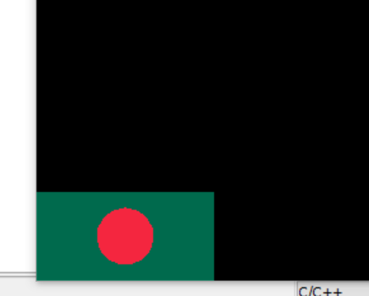

Conculation: First of all I using some the function glutInit (&argc, argv). the window size using the function glutInitWindowSize(700, 650).Set the starting position for the window using the function glutInitWindowPosition (100, 100).Initialize the window and set the title using the function glutCreateWindow(“farzana 2579”).Initialize the myInit() function and perform the following steps:Set the background color to orange using the function glClearColor(0.0f, 0.0f, 0.0f, 0.0f). Initialize the myDisplay() function and perform the following steps:Clear the screen using the function glClear(GL_COLOR_BUFFER_BIT).Set the drawing color to glColor3f(0.9569,0.1490,0.2471). glTranslatef(10,5,0); glutSolidSphere(3.25,15,15); glOrtho(0.0, 100.0, 0.0, 80.0, -10.0, 10.0).